Ben Bode
Module 2.2 assignment - debugging an old assignment from a different class

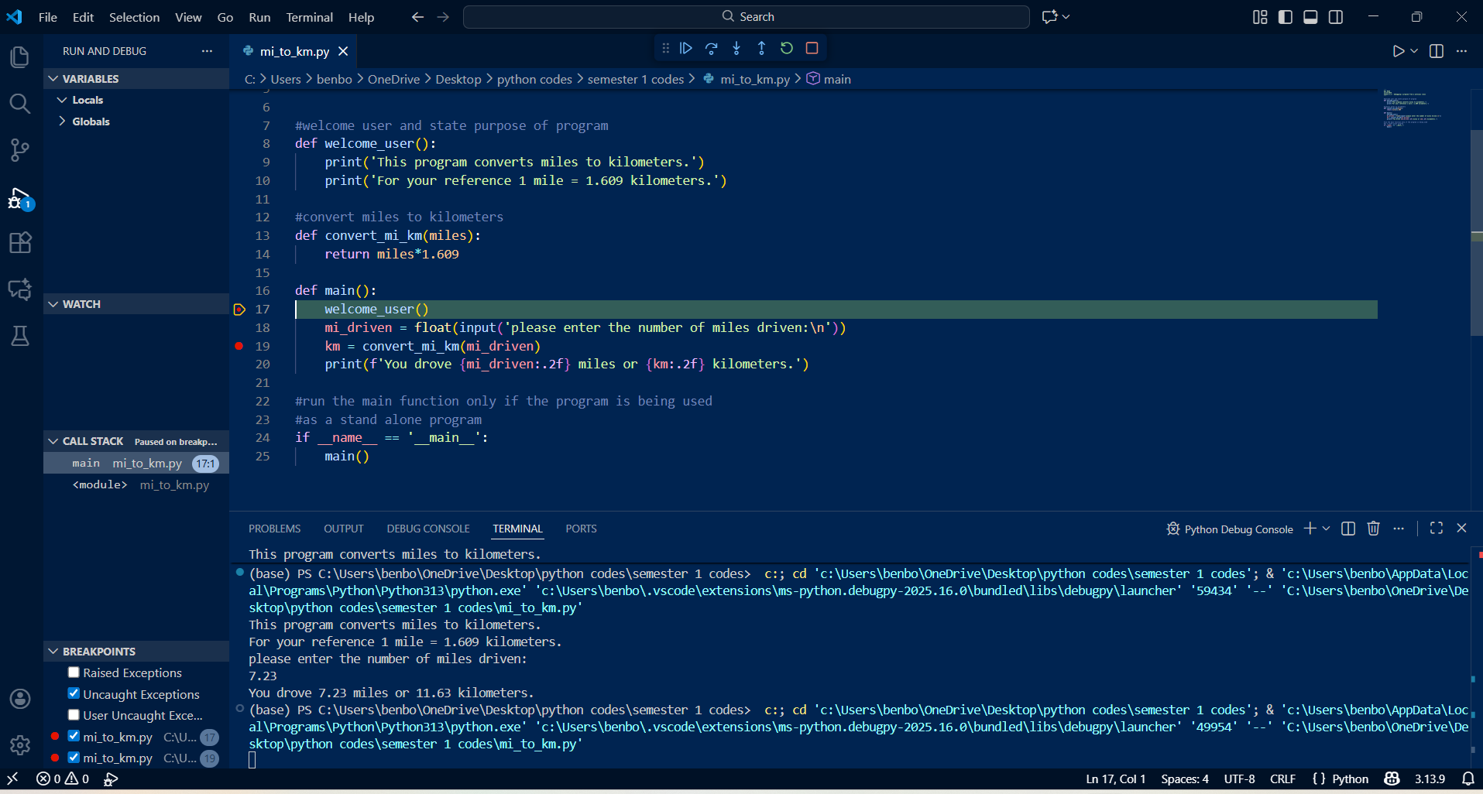
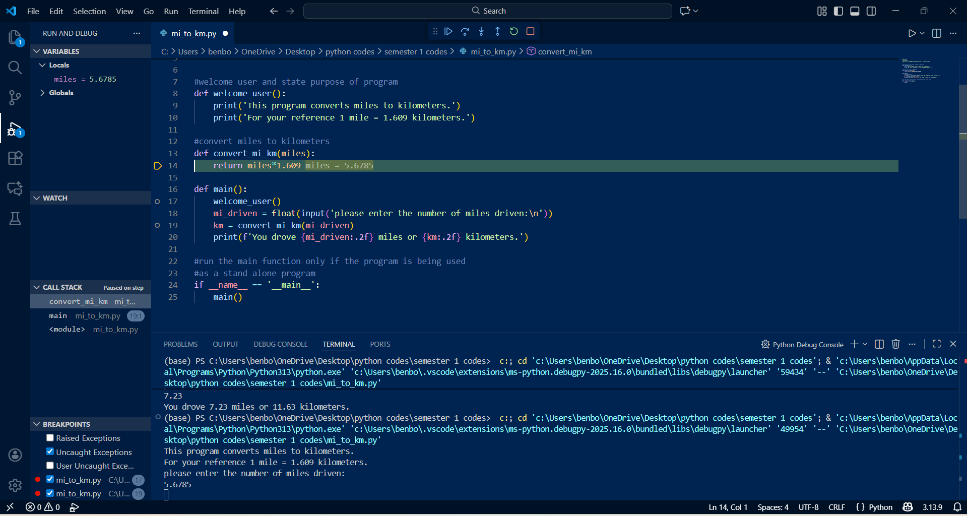
This is what happens if you make a syntax error and try and debug, it won’t run:
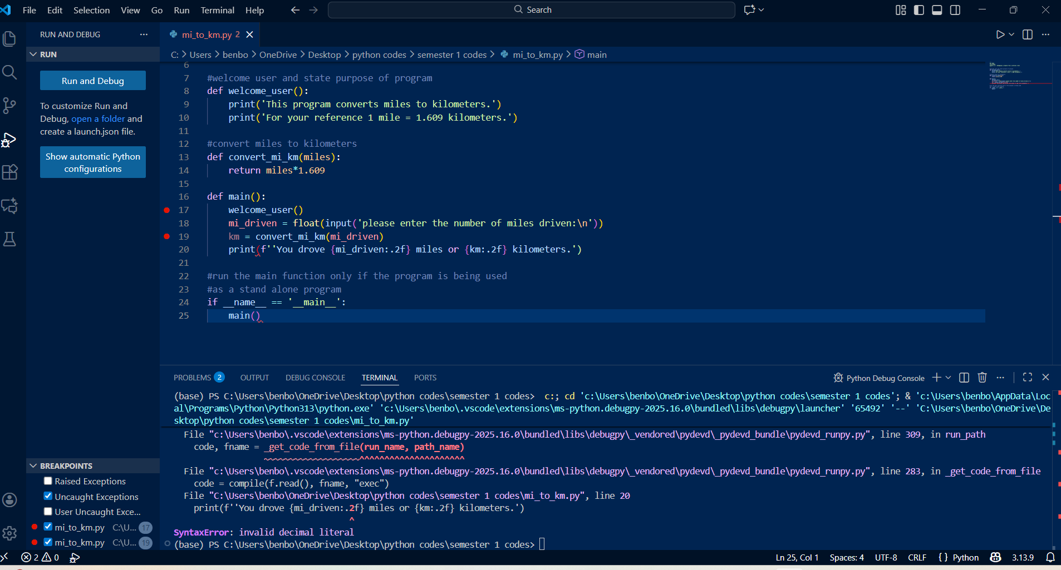
This is finishing the program in the debugging window:
